LOGIC GATES

OR GATE

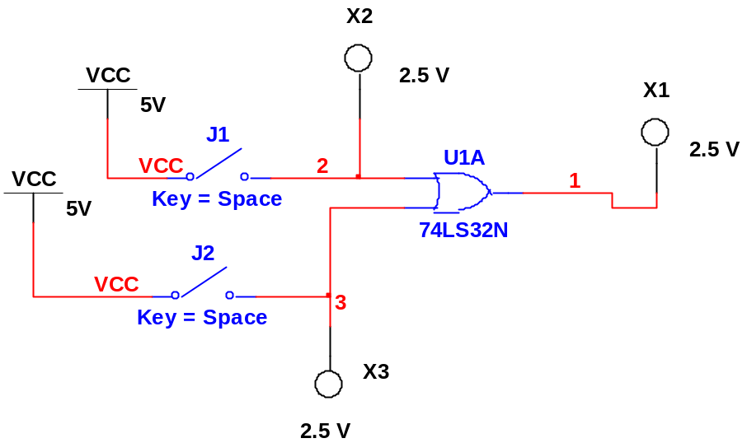

AND GATE

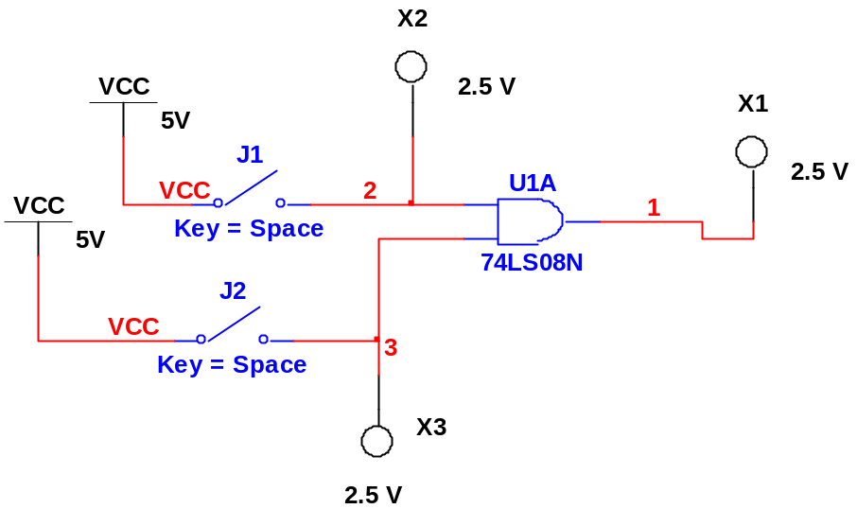

NAND GATE

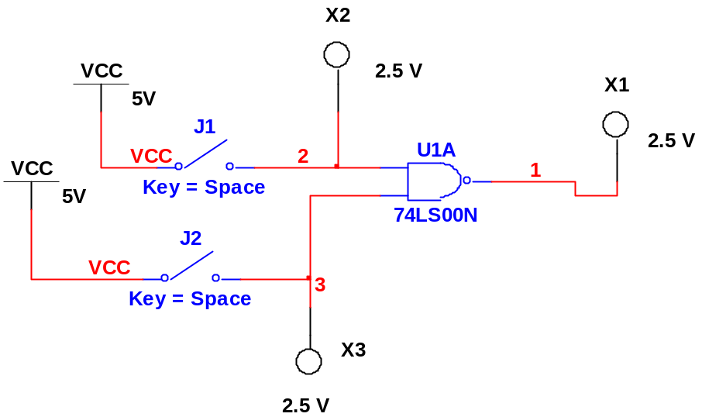

EXOR GATE

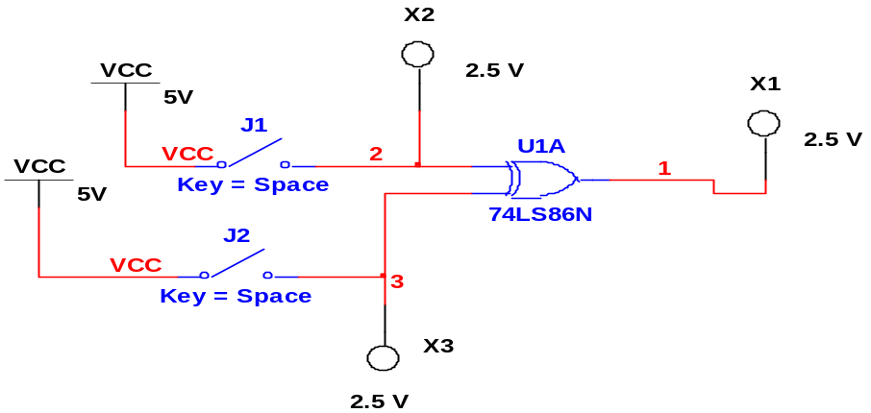

EX-NOR GATE
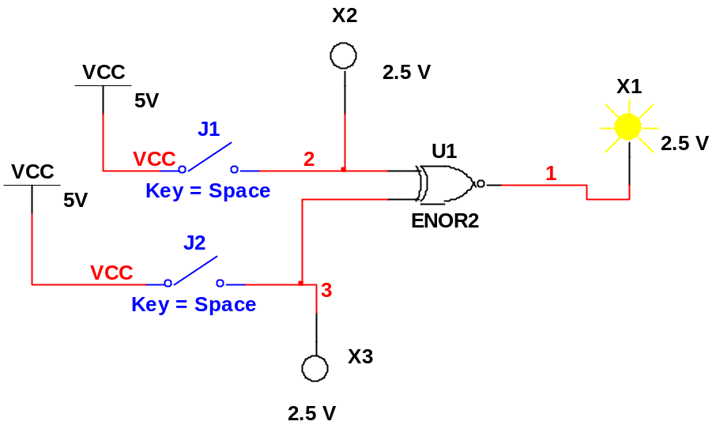

NOR GATE

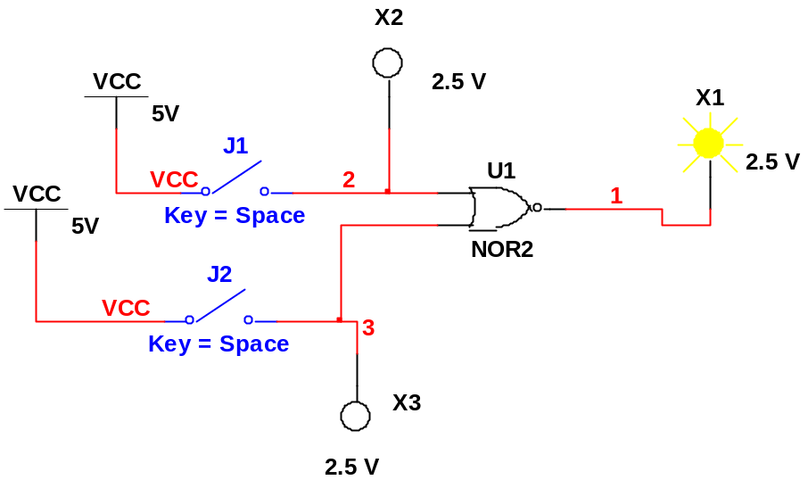

INVERTER

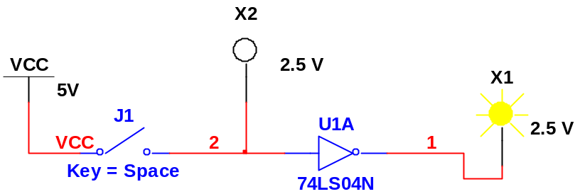
To Find Ex-Nor Gate follow the procedure given

- Go to Place Component and go to MISC Digital and select TIL and Type ENOR as shown below

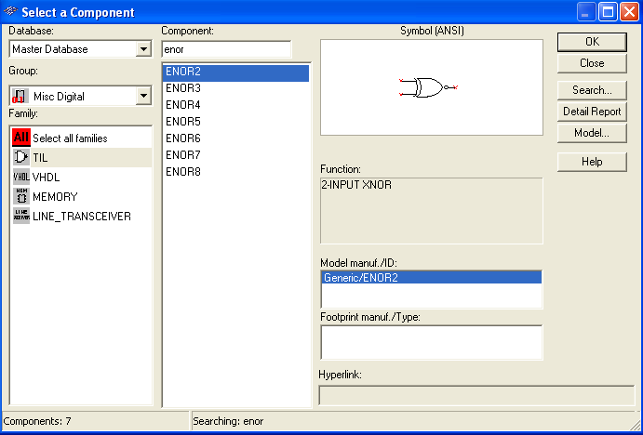

2. Give the wiring connections and indicators and start the simulation.

